**Name: HAMMAD TAHIR**

**Intern ID: TN/IN01/PY/006**

**Email ID : BEINGHAMMAD345@GMAIL.COM**

**Internship Domain : PYTHON**

**Task Week : 03**

**Instructor Name : HASSAN ALI**

**Task 1 :**

Create a calculator that accepts two numbers and an operator (+, -, *, /, %, //, **).

Perform the operation and display the result.

Handle division by zero safely.

**Solution :**

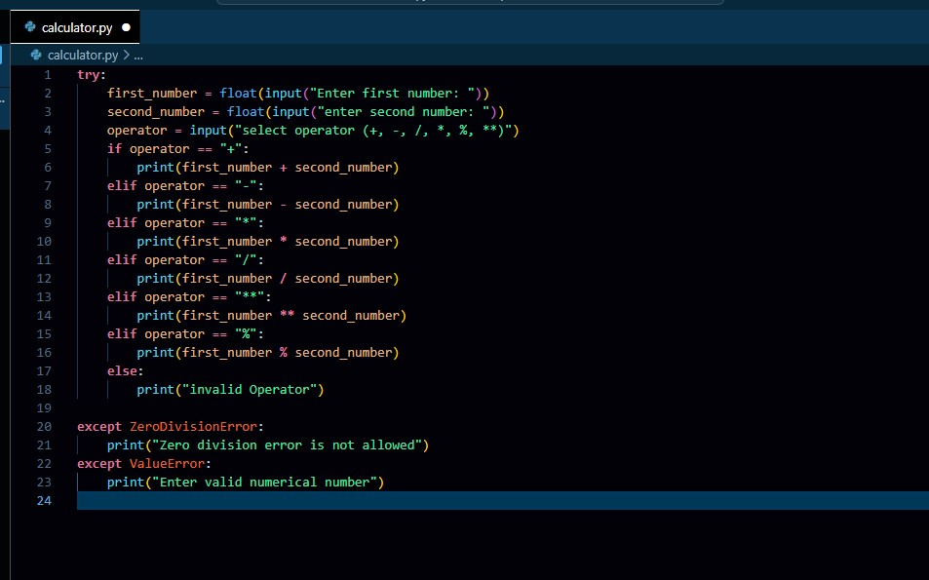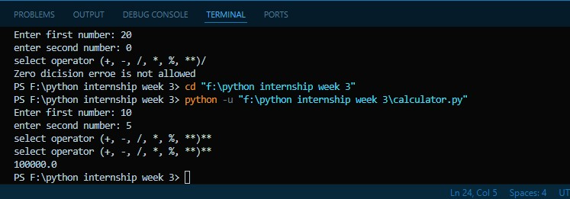

**Task 2:**

Take marks of 3 subjects.

Calculate total, percentage and assign grade:

A (>=85), B (>=70), C (>=50), Fail (<50).

**Soution:**

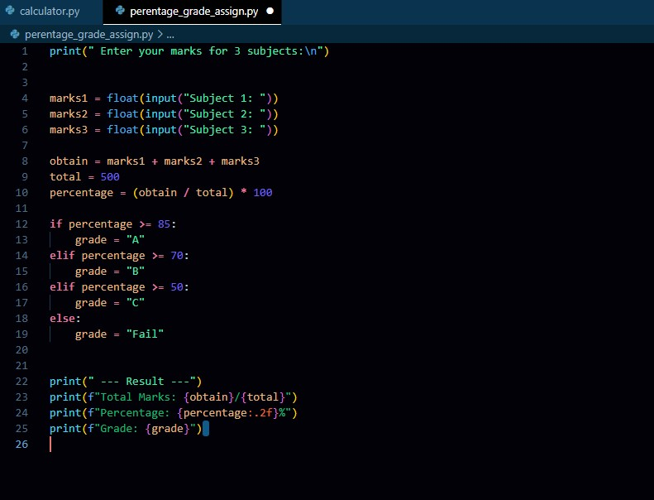

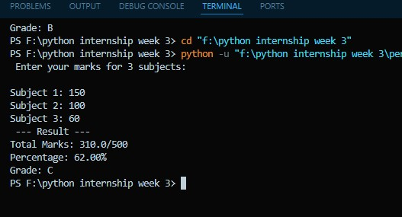

**Task 3:**

Ask user for monthly income and expenses.

Calculate savings and classify:

>10000 = Saving Well, 5000–9999 = Average, <5000 = Try to Save.

**Solution:**

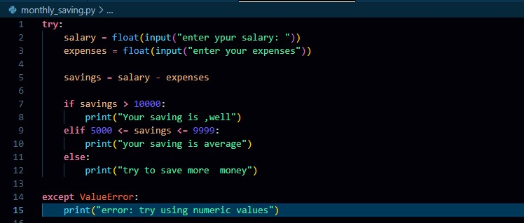

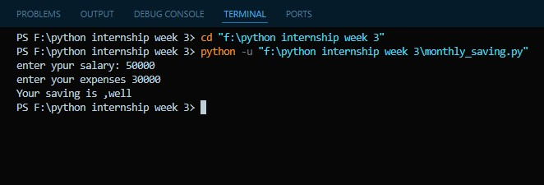

**Task 4:**

Build a login system. Ask username & password.

If username = 'admin' and password = '1234', print Access Granted.

Else, Access Denied.

**Solution :**

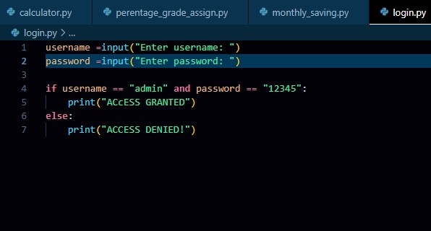

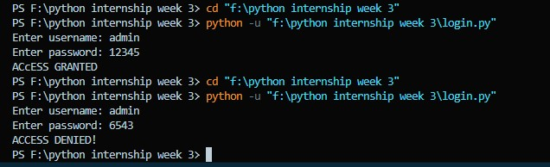

**Task 5:**

Ask user for attendance (%) and final marks.

If attendance ≥ 75 and marks ≥ 50 → Promote

Else → Not promoted.

**Solution:**

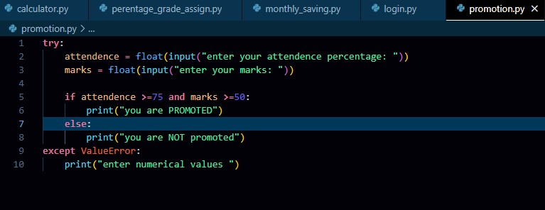

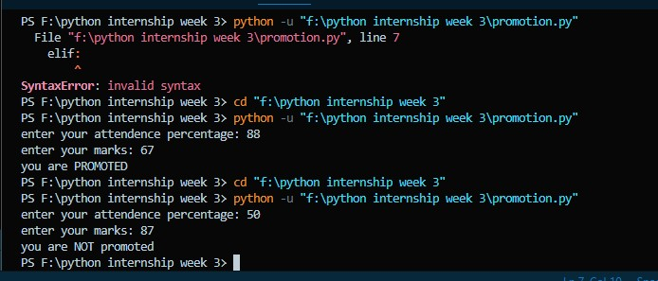

**Task 6:**

Billing system:

Take number of products and total price.

If price > 1000 and products > 3 → 15% discount

If price > 500 → 10% discount

Else → No discount.

Show final bill.

**Solution** :

